Dear Prospective Sponsor,

Thank you for your interest in sponsoring NZDG Tour Event Name Here

Info about your event here:
Something like…. “This is a two day event where we are looking to attract disc golfers from around New Zealand as well as overseas professional players. The event will be marketed NZ wide as well as in Australia, Europe and the USA. There will be comprehensive social media coverage leading up to and during the event on the NZ Disc Golf page and other regional disc golf pages.”

Info about Disc Golf here:
Something like…

So what is disc golf?
Disc golf is played much like traditional golf but instead of a ball and clubs, players use a flying disc, or Frisbee. The goal is the same as golf, simply throw the disc into a target in the fewest number of throws. Like golf, there are drivers, irons (mid-range) and putters.

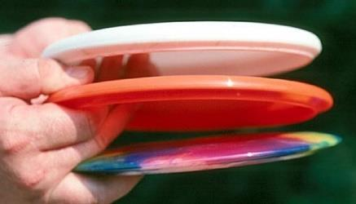 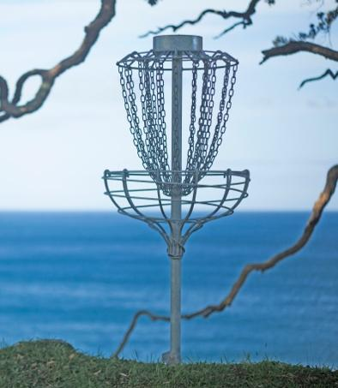Putter, midrange and driver. Disc Golf Basket Target

We are excited to be offering the following sponsorship options:

Primary Naming Sponsor
$Cash amount is up to the TD and organising team. (1 available)

The primary naming sponsor will receive the following benefits -

Naming rights for the event. i.e. NZDG Tour Event Name Here brought to you by ‘sponsors company name’. An A3 poster will be produced and distributed around NZ and overseas.

- Large title positioned logo to be included with all branding leading up to the event. Inclusion in marketing material on the NZDG website and social media pages.
- Social media advertising with an over 1000 person reach on the NZDG Facebook page – add in your Facebook page followers number here
- Press release prior to, during and after the event
- Banner Signage and or teardrop flags (if provided) around the course and at the HQ
- Mention by the Tournament Director over the weekend
- Spot prize giveaways / product sampling

- Your logo on signage on 5 holes on the course

Eagle Sponsorship - level
$Cash amount is up to the TD and organising team. (2 available)

Eagle sponsors will receive the following benefits /-

- Medium sized logo to be included on all branding leading up to the event. Inclusion in marketing material on the NZDG website and social media pages. An A3 poster will be produced and distributed around NZ and overseas.
- Social media advertising and press release prior to, during and after the event
- Banner Signage and or teardrop flags (if provided) around the course and at the HQ
- Mention by the Tournament Director over the weekend
- Spot prize giveaways / product sampling
- Your logo on signage on 3 holes on the course

Birdie Sponsorship -
$Cash amount is up to the TD and organising team. (8 available)

Birdie sponsors will receive the following benefits -

- Smaller logo to be included on all branding leading up to the event. Inclusion in marketing material on the NZDG website and social media pages
- Your logo on signage on one of the holes on the course
- Social media advertising and press release prior to, during and after the event

- Mention by the Tournament Director over the weekend
- Spot prize giveaways / product sampling

Par Sponsorship / hole sponsorship - $Cash amount is up to the TD and organising team. (8 available)

- Social media advertising and press release prior to and post event
- Your logo on signage on one of the holes on the course

I look forward to hearing from you regarding the above.

Kind regards

Tournament Director

